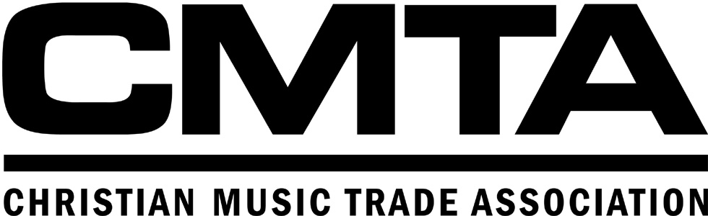

ORGANIZATIONAL HIGHLIGHTS

March 1993 Organizational Charter created

July 1995 Christian SoundScan launched

August 1995 First Christian SoundScan Chart with Christian retail data printed in Billboard

August 1996 First Gospel SoundScan Chart with Christian retail data printed in Billboard

June 1997 First Gospel label invited to join board

January 1998 CMTA Marketing Director hired

July 1998 SoundScan Manager hired

Spring 1998 General Markets Committee created

April 1998 NARM/Dove Awards campaign launched

September 1998 Standard Categorization of Music established

March 1999 NARM Meeting w/Top 15 accounts held to create CCM and Gospel racks

November 1999 Began inclusion of Venue Sales in SoundScan

March 2000 Industry Video, “The World’s Fastest Growing Music Audience” created

April 2000 Began BDS Monitoring

Fall 2000 Barna Research Study commissioned

February 2001 UPC Standard established

March 2001 By Laws amended

March 2001 Third Day & Jennifer Knapp performed at NARM Opening Session

May 2001 Began Insight access

July 2001 Latin chart added to Christian SoundScan

April, 2002 Began SoundScan in-house processing

March 2002 Nicole C. Mullen & Jars of Clay performed at NARM Opening Session

January 2003 BDS Chart published in GMAil

August 2003 Hot Christian Singles & Tracks and Hot Christian Adult Contemporary charts debuted on Billboard.com

August 2003 Incorporated Anti-Piracy message into CD packaging

February 2004 Operational Guidelines approved

April 2004 Anti-piracy campaign officially launched with press conference at GMA Week

May 2004 By-Laws amended

June 2004 Christian BDS included in The Billboard Hot 100

July 2004 CMTA Units Shipped Report created

April 2005 Hot Gospel Tracks chart debuted in Billboard

July 2005 R&B/Hip Hop, Digital Albums, Digital Tracks, and Top Christian/Gospel Albums charts to SoundScan system

October 2005 SoundScan Venue Sales policy amended, allowing labels to submit venue sales without a retailer

February 2006 National Council for Faith Based Youth’s “Ethical Revolution” anti-piracy partnership began

September 2006 CBA/CMTA Music Summit launched long-term campaign to increase Christian retail music sales

July 2007 CBA/CMTA Releases “Sound Decisions: A Survey of Christian Music Consumers in Christian Retail”

October, 2007 SoundScan programming changes enable CMTA to process 13-digit UPCs
December, 2007 CMTA signs on as a supporter of the “Performance Right Act” and the musicFirst Coaltion

